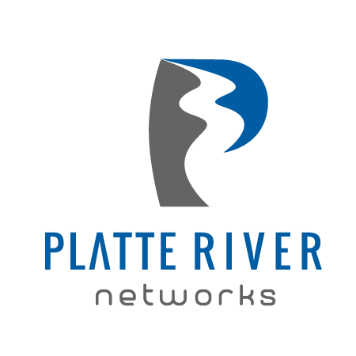

**For Immediate Release**

February 26, 2017

**Platte River Networks Announces Sponsorship of Big Idea Project Students at Horizon High School**

*Partnership aims to build nation’s future leaders*

**DENVER, CO –** Platte River Networks is excited to announce its second year of sponsorship of Horizon High School in partnership with the Big Idea Project®, a not-for-profit organization that brings businesses and schools together to develop and empower our nation’s future generous leaders.

Through this sponsorship, Platte River Networks will be working with Horizon’s Big Idea Project teachers and students to encourage and advise young leaders. Platte River Networks aims to provide real-world learning opportunities, foster students’ career goals, and build a lasting relationship with Horizon.

“We were honored to first become involved with the Big Idea Project last year as judges for the competition at Horizon High School,” said Brent Allshouse, co-founding partner and CFO of Platte River Networks. “The Big Idea Project empowered the students to work hard as a team and create some amazing ideas, helping them gain confidence and overall leadership skills. We are thrilled to help promote such a valuable and wonderful experience!”

“I was amazed at the extraordinary Big Ideas and the students created and presented during the competition,” said David DeCamillis, VP Sales & Marketing Platte River Networks. “As a judge last year, I had difficulty picking just one winner. The students’ projects were well thought out and executed. I thought they were all worthy of winning!”

Horizon’s Assistant Principal, Kim Brady expressed excitement for the ongoing partnership through Big Idea Project. “Platte River Networks is a local business that is invested in making a difference in the lives our young people. Their communication and collaboration has helped to inspire and mobilize countless future leaders!”

Horizon High School offers the Big Idea Project to students in its SOAR program, a four-year academic program that prepares students for post-secondary enrollment and 21st century leadership experiences. Last year, Horizon’s team won the Big Idea Project State competition and college scholarship.

Big Idea Project is a service learning experience for high school students that moves students from knowledge to behavior change to become the leaders our companies and communities need. Students get their hands dirty, solve tough problems and lead real community impact, all within the context of school. Big Idea Project exists to grow **generous leaders** who lead, live and work from a place of selflessness, empathy and respect for all people. An important part of the model is bridging businesses with schools. Big Idea Project is only three years old, but has a wide reach in 12 schools across six school districts. In three years, over 1,000 students have participated in the project.

“We are excited and proud to foster this important relationship within our local community,” said Tricia Halsey, Co-Founder and Executive Director, Big Idea Project. “We believe the best way to fill our nation’s growing leadership gap is to make it possible for business and education to work together.”

**About Big Idea Project**

Big Idea Project® is a non-profit organization that develops high school students into generous leaders who have the skills and confidence to solve challenging problems. The program is a turn-key co-curricular project facilitated in the classroom in any subject area by teachers. Student teams tackle social issues they care about and form action plans with the help of business mentors. The Big Idea Project is not a pitch contest, but a results contest. Students implement their plans, create storytelling videos and present their real impact on stage for the chance to win a college scholarship. To learn more about Big Idea Project and to see student videos go to [www.bigideaproject.org](http://www.bigideaproject.org). Connect with Big Idea Project on [Twitter](https://twitter.com/generousleaders) and [Facebook](https://www.facebook.com/BigIdeaProject).

**About Platte River Networks**

For the past 15 years, Platte River Networks has provided complete IT and telecom managed services to companies of all sizes from small to enterprise across the entire USA within every industry. Platte River Networks has made a name for themselves when they introduced Intuition in 2007, a proactive monitoring and maintenance suite bundled within the Cloud capable of handling their clients’ entire IT infrastructure. Intuition provides 24x7 remote and onsite management of network environments including monitoring, help desk and procurement.

Platte River Networks has won over 25 industry, growth and service awards in the past three years both locally and nationally.

[www.platteriver.com](http://www.platteriver.com)

###

**Media Contact**

**Big Idea Project**

Tricia Halsey  
Phone: (818) 795-7362  
Email: [Tricia@bigideaproject.org](mailto:Tricia@bigideaproject.org)

**Media Contact**

**Platte River Networks**

David DeCamillis

VP Sales & Marketing

Phone: (303) 255-1941

Email: [David@platteriver.com](mailto:David@platteriver.com)